TASK 2: Perform white-box testing
Create a conference as a Chair

Test case 0001:
Test if the name can be empty
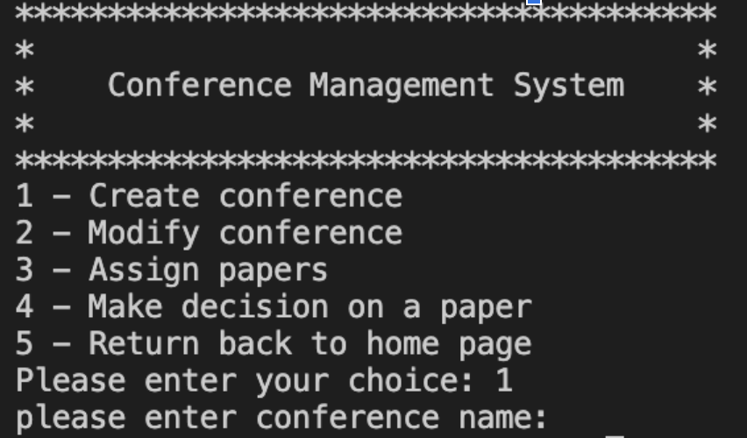
empty approved and go on enter title
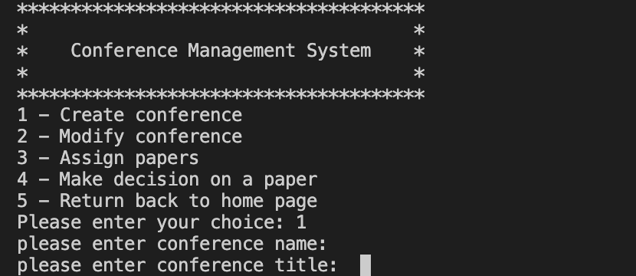

Test case 0002:
Test if the name can only be number
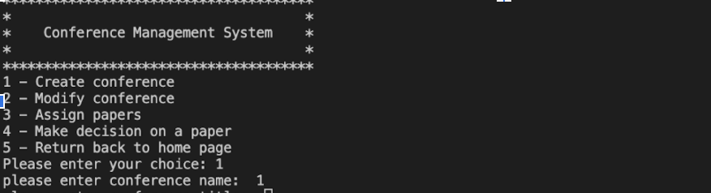
number approved and go on enter title
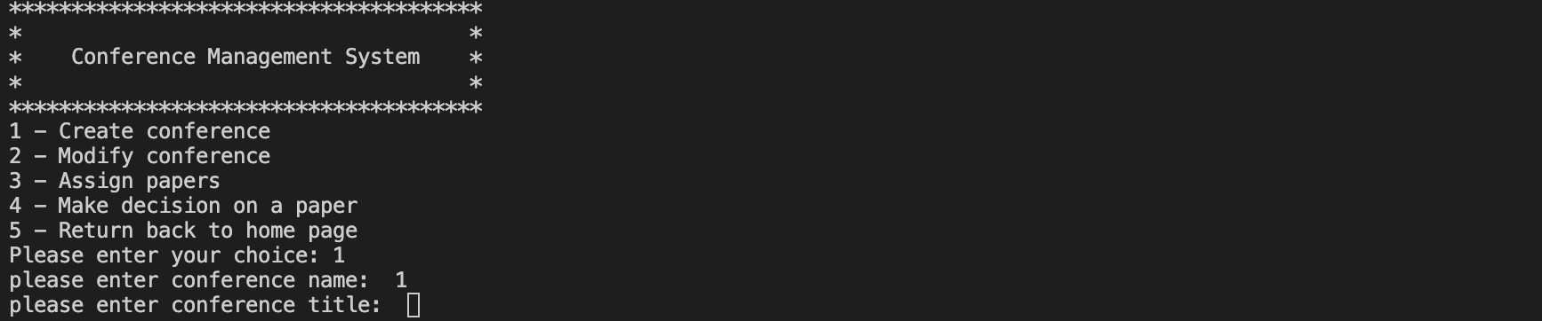

Test case 0003:
Test if the name can be only special characters
special characters approved and go on enter title

Test case 0004:
Test if the name can be digits, alphabets and special characters
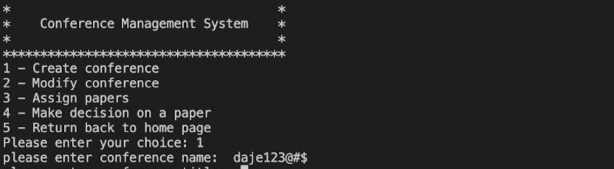
name approved and go on enter title
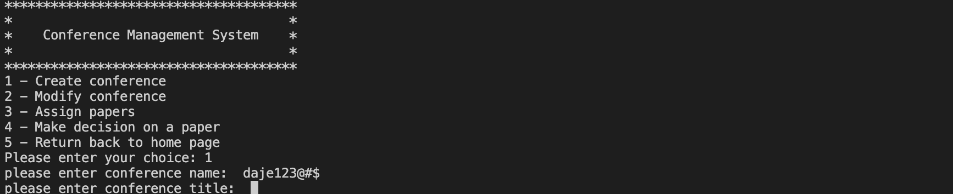

Test case 0005:
Test if the name can only be alphabets
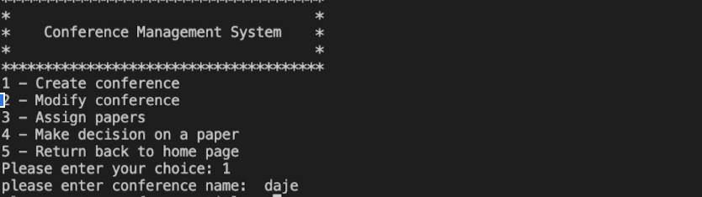
name approved and go on enter title
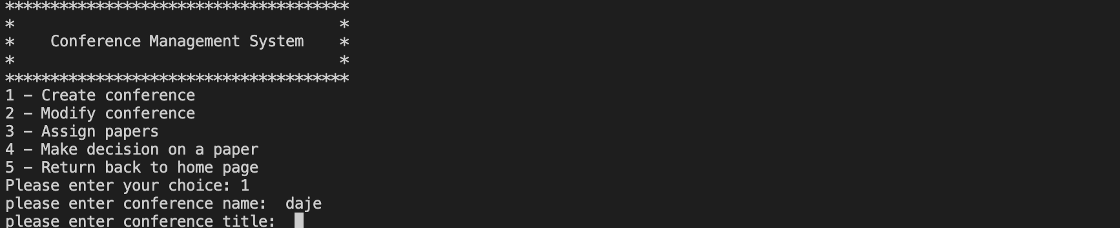

Test case 0006:
Test if the title can be empty
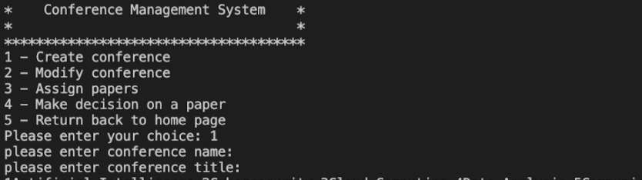
empty approved and go on enter topic number
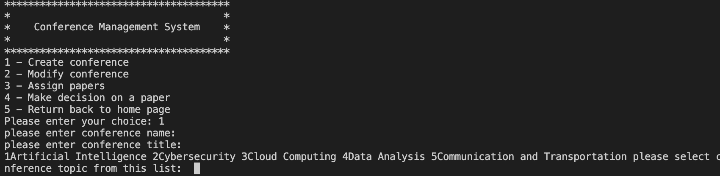

Test case 0007:
Test if the title can only be number
number approved and go on enter topic number

Test case 0008:
Test if the title can be only special characters
special characters approved and go on enter topic number

Test case 0009:
Test if the title can be digits, alphabets and special characters
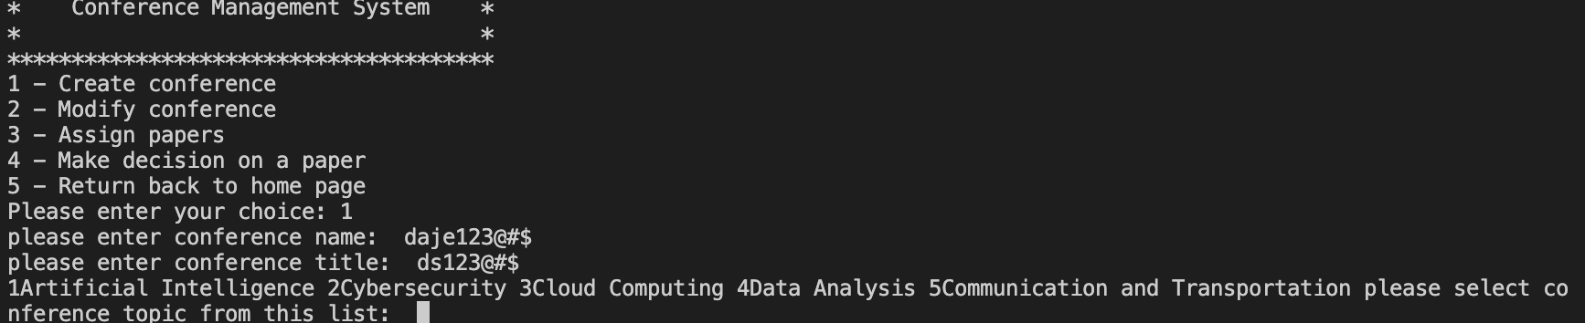

Test case 0010:
Test if the title can only be alphabets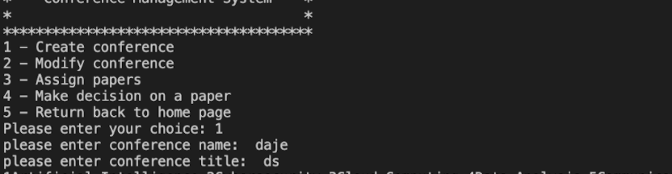
title approved and go on enter topic number
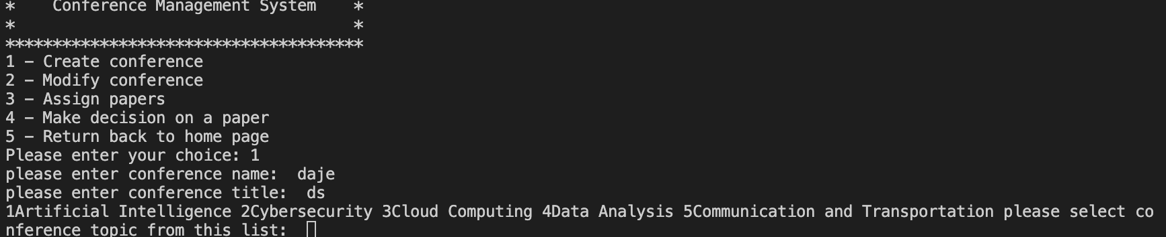

Test case 0011:
Test if the topic number can be empty
please only enter number of choice
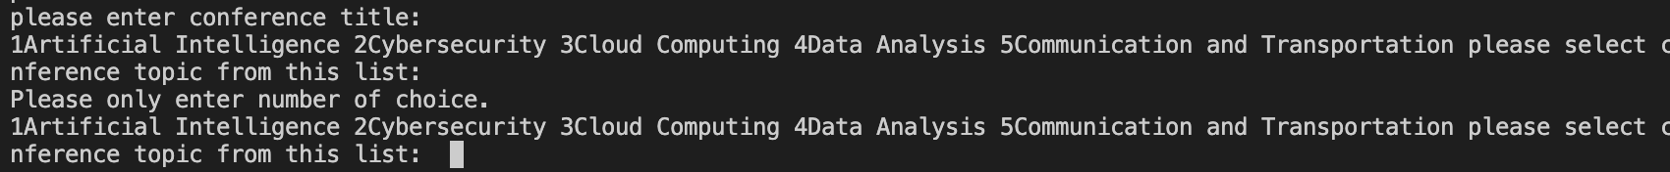

Test case 0012:
Test if the topic number can be beyond the number of the list
please only enter number of choice
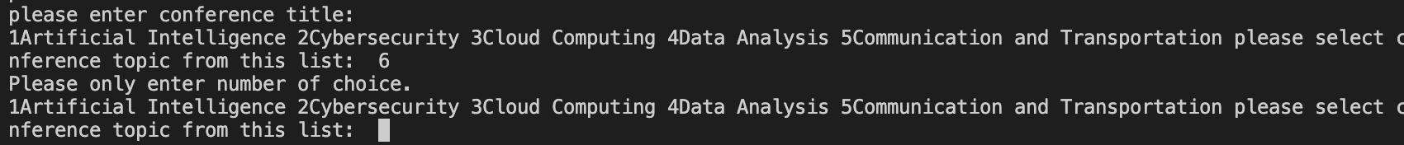

Test case 0013:
Test if the topic number can be string
please only enter number of choice

Test case 0014:
Test if the topic number is from 1 to 4
topic number approved

Test case 0015: PASSED
Test if the paper submission due date can be empty
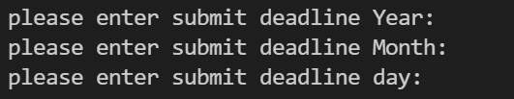
The output is as we expect.
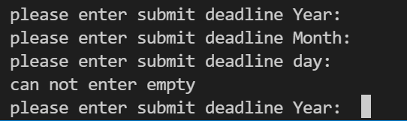

Test case 0016: FAILED
Test if the paper submission due date can be a past date
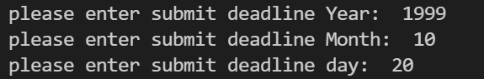
The output is not as we expect.
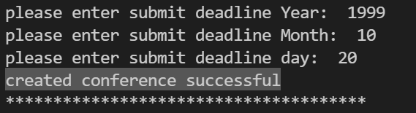
Test case 0017: PASSED
Test if the paper submission due date can include alphabetic characters
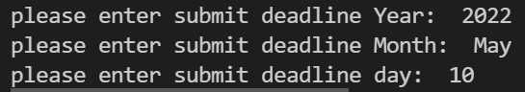
The output is not as we expect.
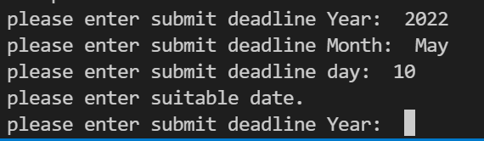

Test case 0018: PASSED
Test if the paper submission due date can include special characters
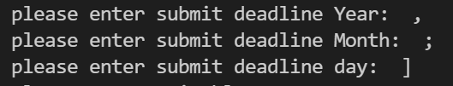
The output is not as we expect.
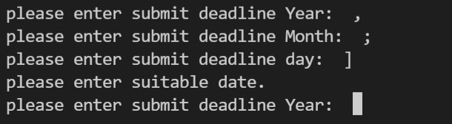

Test case 0019: PASSED
Test if the paper submission due date is of of Australian date format
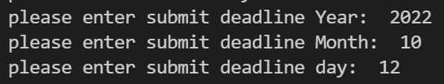
The output is as we expect.
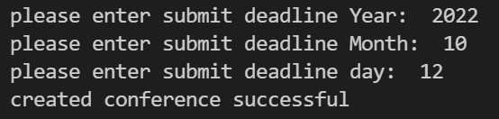
Check with Conference Report:
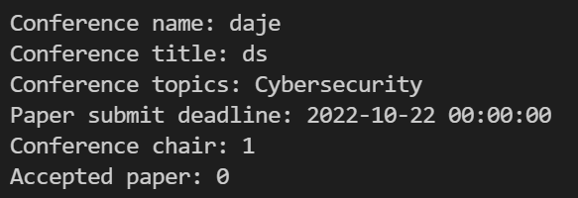

Test case 0020: FAILED
Test if the paper review due date can be empty
Test case 0021: FAILED
Test if the paper review due date can be a past date
Test case 0022: FAILED
Test if the paper review due date can include alphabetic characters
Test case 0023: FAILED
Test if the paper review due date can include special characters
Test case 0024: FAILED
Test if the paper review due date is of of Australian date format

We didn’t implement this attribute. But the test of this attribute is similar to the previous one, so we will fix the bugs and implement this attribute later.

Test case 0025: FAILED
Test if the list of papers submitted can be a string
Test case 0026: FAILED
Test if the list of papers submitted can be a dictionary
Test case 0027: FAILED
Test if the list of papers submitted can be a list
Test case 0028: PASSED
Test if the list of papers submitted can have 0 object

We didn’t implement this attribute in Creating A Conference. But we do have this attribute in our Conference class, and the default of this attribute is empty. So, when the conference is just created and there is no paper submitted to the conference, the Conference Report will be like below:

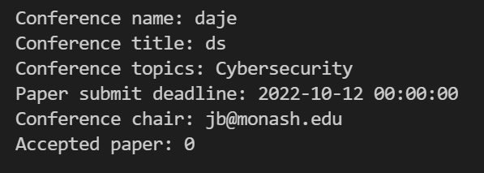

If a few papers have been submitted for the conference, the Conference Report will be like below:

